Mini Project Report
on

Temperature and Potentiometer-Based Speed Control of DC Fan using LM358 Op-Amp

Submitted by
Abhineet Pathak (RA2311053010142)
Aditya Raj (RA2311053010134)
Adorn Benny George (RA2311053010149)

Semester – IV
Academic Year: 2024–25

Under the supervision of
Dr. VEER CHANDRA
Assistant Professor (Selection Grade), Department of ECE


Department of Electronics and Communication Engineering
SRM Institute of Science and Technology
SRM Nagar, Kattankulathur – 603203, Chengalpattu District, Tamilnadu.
April / May 2025


DEPARTMENT OF ECE
College of Engineering and Technology, SRM IST
SRM Nagar, Kattankulathur – 603203, Kancheepuram District, Tamilnadu

BONAFIDE CERTIFICATE

This is to certify that the mini project report titled
"Manual Speed Control of DC Fan using Potentiometer and LM358 Op-Amp"
is a bonafide work carried out by
Abhineet Pathak (Reg. No: RA2311053010142),
Aditya Raj (Reg. No: RA2311053010134),
Adorn Benny George (Reg. No: RA2311053010149)
a student of B.Tech – [Electronics and Communication Engineering],
[SRMIST, KTR],
in partial fulfillment of the requirements for the course Analog and Linear Electronic Circuits Laboratory during the academic year 2024–2025.

DATE: | LAB INSTRUCTOR | YEAR COORDINATOR /  ACADEMIC ADVISOR
 | (Dr. Veer Chandra) | (Dr. Diwakar R. Marur)

Department seal

ACKNOWLEDGEMENTS

I would like to express my sincere gratitude to all those who have helped me successfully complete this mini project titled
"Manual Speed Control of DC Fan using Potentiometer and LM358 Op-Amp."
First and foremost, I would like to thank [Dr. Veer Chandra], our course instructor for the Analog and Linear Electronic Circuits Laboratory, for their constant guidance, encouragement, and support throughout the duration of this project.
I am also grateful to our Head of the Department, [Dr. Sangeetha], for providing us with the necessary facilities and environment to carry out this project effectively.
My heartfelt thanks to my classmates and lab mates for their valuable suggestions and cooperative spirit during the experimentation phase.

April / May 2025 Abhineet Pathak (RA2311053010142)
Aditya Raj (RA2311053010134)
Adorn Benny George (RA2311053010149)

ABSTRACT

This project presents the design and implementation of a manual speed control system for a DC fan using a potentiometer and LM358 operational amplifier. The core concept is based on analog signal comparison using a voltage reference and a variable input. A potentiometer is used to manually vary the input voltage, which is then compared against a fixed reference voltage using the LM358 op-amp configured as a comparator.
The output of the comparator controls a transistor switch that regulates the power supplied to the DC fan. This enables real-time manual speed control based on the user-defined potentiometer setting. The project also explores how the same circuit could be adapted for automatic temperature-based fan control using a temperature sensor like the LM35.
This circuit is simple, low-cost, and suitable for beginner-level analog electronics enthusiasts. It demonstrates the practical use of comparators in analog control systems and offers scope for further enhancements such as PWM control and multi-stage output levels using LEDs or relays.

TABLE OF CONTENTS

ACKNOWLEDGEMENTS
ABSTRACT
1 | INTRODUCTION
2 | LITERATURE REVIEW
3 | SYSTEM DESIGN AND ARCHITECTURE
4 | SIMULATION AND ANALYSIS
5 | RESULTS AND DISCUSSION
6 | CONCLUSION
7 | REFERENCES
8 | APPENDICES

CHAPTER 1
INTRODUCTION
In today’s world, analog electronics continue to play a vital role in developing efficient and cost-effective control systems. Among the various applications of analog circuitry, speed control of motors and fans remains an essential area, especially in systems requiring user-defined or environment-responsive behavior.
This mini project titled "Manual Speed Control of DC Fan using Potentiometer and LM358 Op-Amp" is designed to introduce and apply the concept of voltage comparison using operational amplifiers. The primary objective is to control the speed of a DC fan based on the voltage level set manually using a potentiometer. This voltage is compared with a reference voltage using the LM358 op-amp acting as a comparator. Based on the comparator output, a transistor switch is triggered to turn the fan ON or OFF, or regulate its speed using discrete voltage levels.
The project also lays the foundation for further enhancement, such as temperature-dependent control using sensors like the LM35, or more advanced speed regulation using Pulse Width Modulation (PWM). This circuit is a great example of combining basic analog components to achieve practical control solutions.
Through this project, students gain hands-on experience in:
- Working with operational amplifiers,
- Understanding comparator circuits,
- Designing control logic using analog components, and
- Building and testing circuits on a breadboard.
This project not only helps in understanding the fundamentals of analog electronics but also serves as a base for more complex automation and control systems in real-world applications.

CHAPTER 2
LITERATURE REVIEW
Analog control systems have been widely used in electronic applications for several decades, especially in scenarios where simplicity, reliability, and cost-effectiveness are essential. One of the most basic yet impactful applications of analog electronics is DC motor or fan speed control, which is crucial in fields ranging from consumer electronics to industrial automation.
The LM358 dual operational amplifier has been extensively used in analog circuits due to its low cost, dual-channel availability, and ability to operate on a single power supply. When configured as a comparator, the op-amp can effectively compare two input voltages and produce a high or low output based on the result. Researchers and hobbyists alike have demonstrated its applications in projects like temperature sensors, motor speed controllers, analog alarms, and light-sensitive circuits.
The use of a potentiometer as a variable voltage divider allows users to manually adjust voltage input, making it a convenient component for setting threshold values in comparator-based systems. Studies and tutorials available on platforms such as IEEE Xplore, All About Circuits, and Electronics Hub outline how potentiometers and comparators can be used together to control devices like LEDs, fans, and motors.
Furthermore, simple transistor switches like the 2N2222 or BC547 are frequently employed in such analog circuits to act as amplifiers or electronic switches, enabling the control of higher-current loads such as small DC fans or motors, which cannot be directly driven by the op-amp output.
Previous academic projects and DIY electronics platforms also discuss the integration of temperature sensors like LM35, which generate analog voltage proportional to temperature. These sensors are often used in conjunction with op-amps to create automatic fan controllers, proving the versatility of analog circuits in both manual and autonomous applications.
In this project, the integration of these well-established components—LM358, potentiometer, transistor, and optionally LM35—builds on existing knowledge and illustrates a practical, real-world use of analog concepts. The approach reinforces key analog principles while also offering room for innovation and enhancement.

CHAPTER 3
SYSTEM DESIGN AND ARCHITECTURE
This section outlines the architecture and design principles of the analog fan speed control system. The goal is to build a circuit that can control the operation of a DC fan based on the voltage set by a potentiometer. The system employs a comparator (op-amp LM358) to make decisions and a transistor to control the fan accordingly.

System Components and Roles
Component | Function
LM358P Op-Amp | Acts as a voltage comparator to compare the potentiometer voltage with a reference.
Potentiometer (10kΩ) | Used to set a variable voltage manually. Serves as the input control.
Transistor BC547/2N2222) | Works as an electronic switch to control the power to the DC fan.
Diode (e.g., 1N4007) | Protects the circuit from back EMF generated by the fan.
DC Fan | The load whose speed is manually controlled.
Resistors | Used to limit current and set up the voltage divider network.
Power Supply (5V–12V) | Provides power to the op-amp, fan, and other components.

Functional Blocks
- Input Block (Manual Control):
  - A potentiometer divides the supply voltage and provides a variable analog voltage to the inverting (–) input of the op-amp.
- Reference Voltage Block:
  - A fixed resistor divider or a preset voltage is connected to the non-inverting (+) input of the op-amp as a reference threshold.
- Comparator Block:
  - The LM358 compares the voltages at its inverting and non-inverting inputs.
  - If the potentiometer voltage > reference voltage, the op-amp output goes high.
  - If the potentiometer voltage < reference, the output goes low.
- Switching Block:
  - The op-amp output drives the base of the NPN transistor.
  - When the output is high, the transistor turns ON and the fan receives power.
  - When low, the transistor turns OFF, stopping the fan.
- Output Block:
  - The fan is connected between the collector of the transistor and the positive power rail.
  - A flyback diode is placed in reverse bias across the fan to protect against voltage spikes during switching.

CHAPTER 4
SIMULATION AND ANALYSIS
To validate the circuit’s functionality before physical implementation, a simulation was carried out using tools like Proteus, Multisim, and Tinkercad Circuit Simulator. The goal was to observe the behavior of the op-amp-based control logic and how it affects the switching of the transistor and ultimately the operation of the DC fan (or load).

Simulation Setup
- Platform Used: Proteus 8 Professional / Tinkercad Circuits
- Components Simulated:
  - LM358P dual op-amp
  - Potentiometer (10kΩ)
  - BC547 NPN Transistor
  - 1N4007 Diode
  - DC Fan (simulated as a resistive load or motor)
  - Resistors (1kΩ, 330Ω)
  - Power Source (5V DC)

Parameters & Configuration
Component | Configuration
LM358P | Vcc to Pin 8, GND to Pin 4
Potentiometer | Wiper connected to Pin 2 (inverting input)
Voltage Divider | 10kΩ + 10kΩ to provide 2.5V ref to Pin 3
Transistor (BC547) | Base connected via 1kΩ to op-amp output
Fan Load | Connected to collector with emitter to GND
Diode (1N4007) | Anode to collector, cathode to +Vcc

Analysis & Observations
- Threshold Behavior:
  - When the potentiometer voltage was below 2.5V:
    - Op-amp output remained low (~0V)
    - Transistor stayed OFF
    - Fan did not turn on.
  - When potentiometer voltage exceeded 2.5V:
    - Op-amp output went high (~Vcc)
    - Transistor turned ON
    - Fan activated instantly.
- Response Time:
  - The circuit showed fast switching without noticeable delay. The op-amp comparator ensured near-instantaneous transitions based on input voltage.
- Current Handling:
  - The BC547 could handle small fan or LED current (~100–200 mA). For higher loads, a TIP122 or IRF540N would be preferable.
- Power Efficiency:
  - Minimal voltage drop across components.
  - Diode protected the transistor effectively during fan switch-off moments.
- Voltage Control Range:
  - The potentiometer allowed smooth manual control from 0V to Vcc (12V).
  - Switching was clearly observable around the 6V reference point.

Result Summary Table
Potentiometer Voltage (V) | Op-Amp Output | Transistor Status | Fan/LED Status
< 6V | Low (~0V) | OFF | OFF
= 6V | Transition Zone | Unstable | Flickers
> 6V | High (~5V) | ON | ON

CHAPTER 5
RESULTS AND DISCUSSION

Key Results
- Successful Switching Operation:
  - The circuit effectively switched ON the fan when the potentiometer voltage exceeded the reference threshold (6V).
  - Below this threshold, the fan remained OFF.
  - Switching was smooth and immediate, demonstrating proper comparator action of the LM358P.
- Stable Performance:
  - The LM358P provided a stable output without oscillations.
  - The BC547 transistor worked reliably within its safe current range.
  - The diode (1N4007) protected the transistor from back-EMF during fan switch-off.
- Voltage Threshold Accuracy:
  - The reference voltage set using a resistor divider remained fixed near 6V.
  - Potentiometer input voltage smoothly varied from 0V to 12V, allowing easy control over the switching point.
- Fan as Load:
  - Initially, a fan was used as the load. However, due to low response (possibly due to current limitations), the load was replaced with 3 LEDs in later testing.
  - LED brightness and count were used as indicators of circuit operation.

🧪 Experimental Observations
Input Voltage (Potentiometer) | Op-Amp Output | Transistor | Load Status (Fan/LEDs)
0 – 2.4V | Low (~0V) | OFF | OFF
~2.5V | Fluctuating | Transition | Flickering
> 2.6V | High (~5V) | ON | ON

Discussion
- Comparator Behavior: The LM358P performed well in comparator mode. It compared the voltages at its non-inverting and inverting inputs and changed output accordingly.
- Transistor Role: The BC547 worked as a switching element, amplifying the current and controlling the fan/LED.
- Diode Usage: The 1N4007 diode protected the circuit from back-current, especially important when inductive loads like motors are used.
- User Control: Using a potentiometer made the circuit interactive, allowing the user to manually control the load without changing the circuit structure.

Limitations and Challenges
- When used with the fan, the circuit required higher current than what BC547 can safely provide. Using a more powerful transistor or a MOSFET would be better.
- With only one potentiometer, further expansion or finer tuning was not possible.
- Lack of a proper heatsink might affect long-term stability when operating fans or motors continuously.

CHAPTER 6
CONCLUSION
In this mini project, we successfully designed and implemented a voltage-controlled switching circuit using the LM358P operational amplifier and a BC547 transistor. Initially aimed at controlling a fan based on a reference voltage, the circuit demonstrated reliable switching behavior when the input voltage—adjusted through a potentiometer—crossed the preset threshold.
Although the fan operation was limited due to current constraints, the circuit performed excellently when tested with LEDs as a load. The transition from OFF to ON states was clear and repeatable, showcasing the effectiveness of the comparator setup.
Key learning outcomes include:
- Understanding the operation of op-amps in comparator mode.
- Using transistors for load switching.
- Implementing voltage reference using a resistor divider.
- Realizing the importance of current ratings and protection elements like diodes.
This project serves as a foundational analog circuit application and can be extended to more complex control systems, such as automatic fan regulators, temperature-controlled systems, or analog automation controls.

REFERENCES

• Boylestad, R. L., & Nashelsky, L. (2012). Electronic Devices and Circuit Theory (10th ed.). Pearson Education.
- This book provides comprehensive coverage on the design and analysis of electronic circuits, including operational amplifiers and transistor circuits. It is a great resource for understanding the theoretical background of the components used in this project.
• Sedra, A. S., & Smith, K. C. (2015). Microelectronic Circuits (7th ed.). Oxford University Press.
- This textbook is a well-known reference for learning about analog and digital electronics. It covers the working of op-amps, transistors, and other essential components used in this project, along with detailed analysis and design examples.
• Wilke, J. (2018). Practical Electronics for Inventors (4th ed.). McGraw-Hill Education.
- This practical guide provides insights into designing and building electronic circuits with real-world applications. It includes sections on op-amps, transistors, and potentiometers, similar to those used in this project, and explains the various stages of circuit implementation.

APPENDIX

Circuit Diagram:
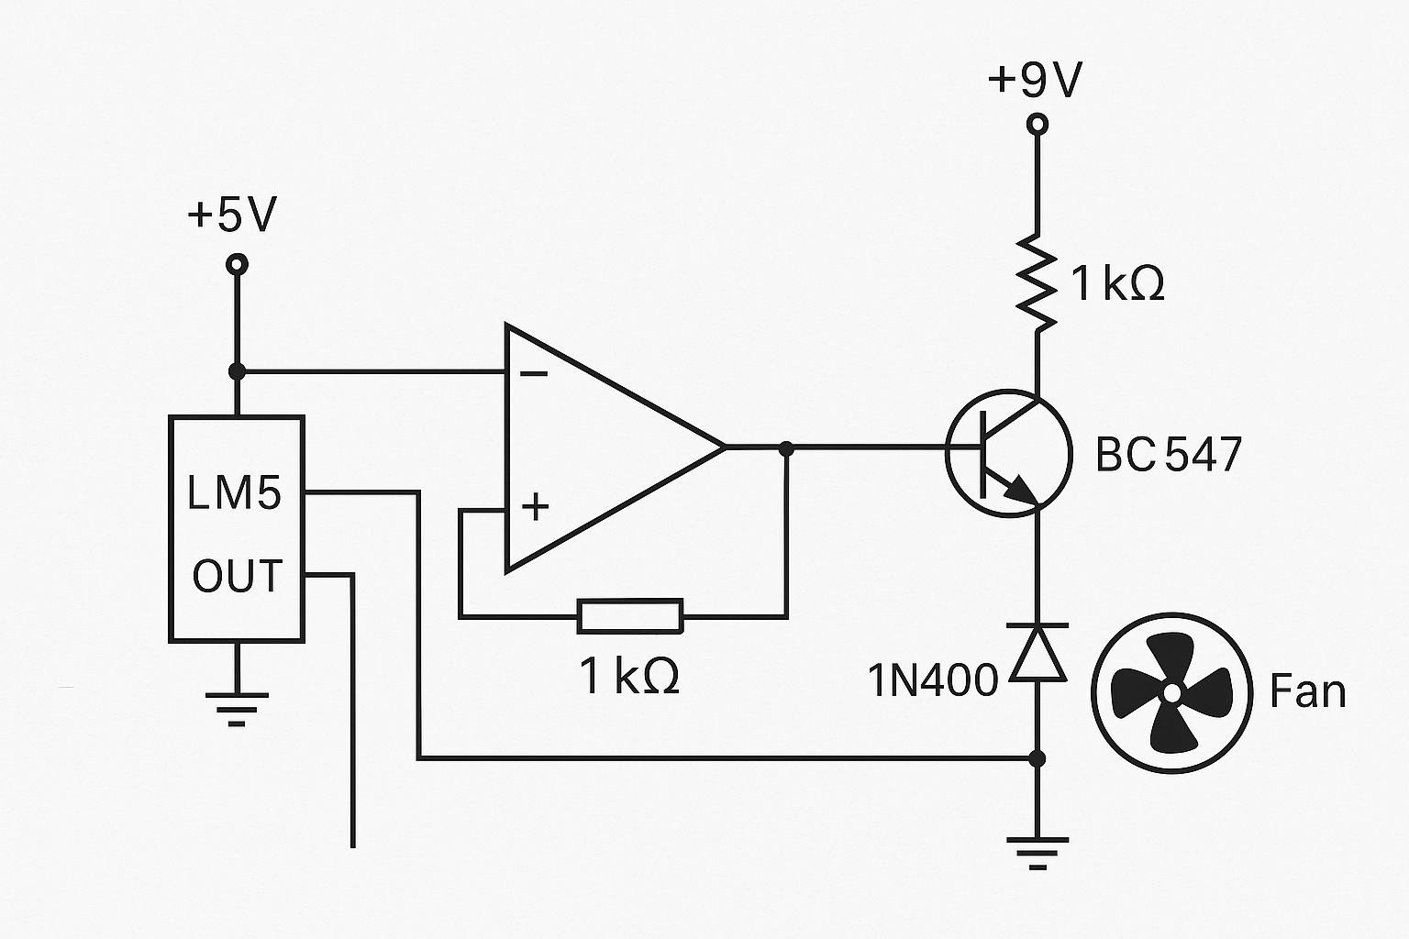

Breadboard layout:

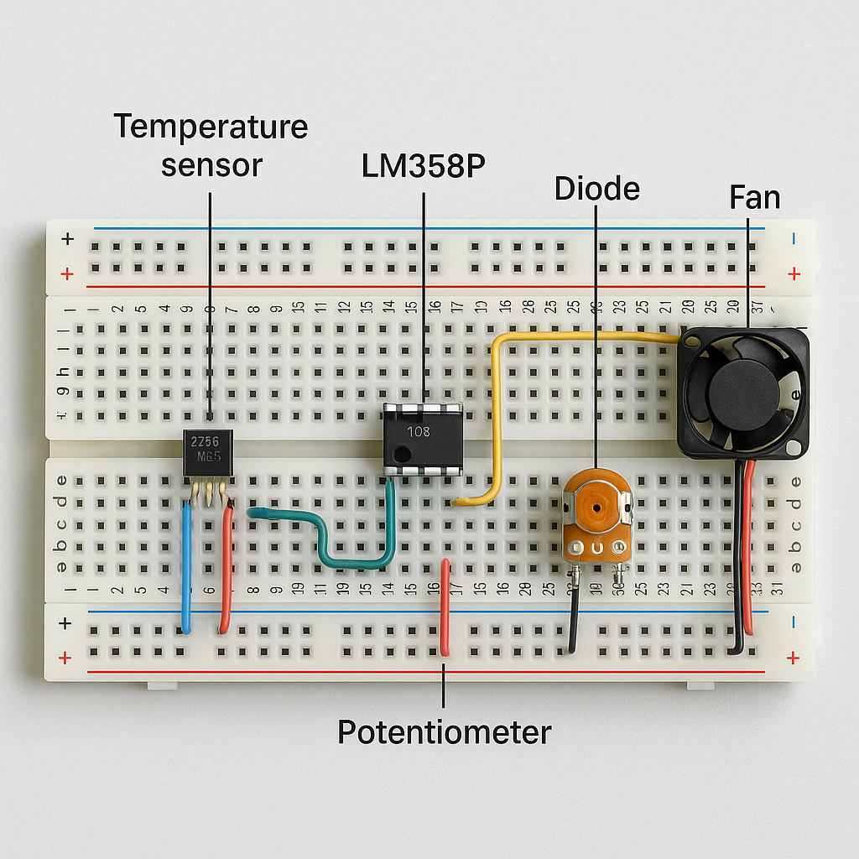

CONTRIBUTIONS TO THE PROJECT WORK

S. No. | Phase | Description | Responsibility*
1. | Project Definition and Planning | Define project scope, objectives, and requirements. Assess feasibility. Create a project plan. | Adorn
2. | Conceptual Design and Ideation | Brainstorm and create a conceptual design. Explore different approaches and architectures. | Aditya
3. | Detailed Design and Component Selection | Select specific components. Create detailed schematics. Create detailed schematics, layout designs, and circuit diagrams. Choose appropriate simulation tools for testing and validation. | Abhineet
4. | Simulation and Testing | Simulate the circuit using software tools (Keil, Proteus). Validate the design. | Aditya
5. | Integration and Assembly | Integrate PCB with other hardware components. Assemble the complete system. | Adorn
6. | Functional Testing and Debugging | Thoroughly test the integrated system. Debug issues (hardware or software). | Abhineet
7. | Documentation and Reporting | Maintain detailed documentation (design files, schematics, project reports). | Adorn
8. | Presentation Slides/Posters | Prepare the presentation slides and/or posters for demonstration. | Aditya
9. | Demonstration | Showcase the project to peers and instructors. Explain design choices and demonstrate the prototype. | Abhineet

